February 04, 2016

**RFID Technology**

**By Chady DAGHER**

**Content**

**CHAPTER 01 What Is RFID?**

**CHAPTER 02 How Do RFID Systems Work?**

**CHAPTER 03 The Different Types of RFID Systems**

**CHAPTER 04 RFID Standards**

**REFERENCES**

**CHAPTER 01  
What Is RFID?**

**Radio frequency identification (RFID) is a form of wireless communication that uses radio waves to identify and track objects**. RFID takes the barcoding concept and digitizes it for the modern world providing the ability to:

•Uniquely identify an individual item beyond just its product type

•Identify items without direct line-of-sight

•Identify many items (up to 1,000s) simultaneously

•Identify items within a vicinity of between a few centimeters to several meters

An RFID system has readers and tags that communicate with each other by radio. RFID tags are so small and require so little power that they don’t even need a battery to store information and exchange data with readers. This makes it easy and cheap to apply tags to all kinds of things that people would like to identify or track.

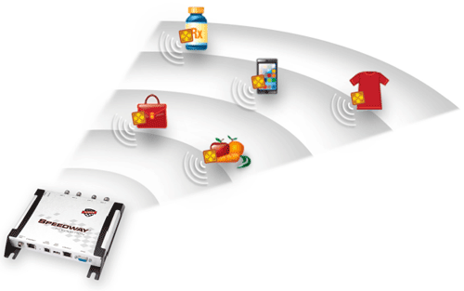

**Why Use RFID?**

RFID technology has the capability to both greatly enhance and protect the lives of consumers, and also revolutionize the way companies do business. As the most flexible auto-identification technology, RFID can be used to track and monitor the physical world automatically and with accuracy.

RFID can tell you what an object is, where it is, and even its condition, which is why it is integral to the development of the Internet of Things—a globally interconnected web of objects allowing the physical world itself to become an information system, automatically sensing what is happening, sharing related data, and responding.

RFID use is increasing rapidly with the capability to “tag” any item with an inexpensive communications chip and then read that tag with a reader. Endless applications range from supply chain management to asset tracking to authentication of frequently counterfeited pharmaceuticals. Applications are limited, in fact, only by the imagination of the user.

**RFID Applications**

RFID can help:

•Automate inventory and asset-tracking in healthcare, manufacturing, retail, and business sectors

•Identify the source of products, enabling intelligent recall of defective or dangerous items, such as tainted foods, defective toys, and expired or compromised medication

•Prevent use of counterfeit products in the supply chain

•Improve shopping experience for consumers, with fewer out-of-stock items and easier returns

•Provide visibility into the supply chain, yielding a more efficient distribution channel and reduced business costs

•Decrease business revenue lost to theft or inaccurate accounting of goods

•Improve civilian security through better cargo monitoring at ports

•Wirelessly lock, unlock and configure electronic devices

•Enable access control of certain areas or devices

•Access management

•Tracking of goods

•Tracking of persons and animals

Whatever the application, RFID has the potential to increase efficiency of operations, improve asset visibility and traceability, decrease reliance on manual processes, reduce operations costs, and provide useful data for business analytics.

**CHAPTER 02  
How Do RFID Systems Work?**

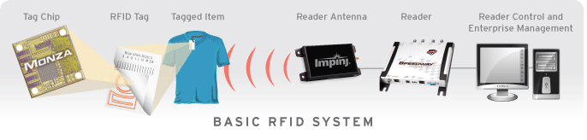

**A basic RFID solution includes:**

**Tag** **Reader**

Tag chips or integrated circuits (ICs) Reader antenna

Tag antennas Reader control & application software

**RFID Solutions**

In a basic RFID system, tags are attached to all items that are to be tracked. These tags are made from a tiny tag-chip, sometimes called an integrated circuit (IC) that is connected to an antenna that can be built into many different kinds of tags including apparel hang tags, labels, and security tags, as well as a wide variety of industrial asset tags. The tag chip contains memory which stores the product's electronic product code (EPC) and other variable information so that it can be read and tracked by RFID readers anywhere.

An RFID reader is a network connected device (fixed or mobile) with an antenna that sends power as well as data and commands to the tags. The RFID reader acts like an access point for RFID tagged items so that the tags' data can be made available to business applications.

**RFID Tags**



An RFID tag is comprised of an integrated circuit (called an IC or chip) attached to an antenna that has been printed, etched, stamped or vapor-deposited onto a mount which is often a paper substrate or PolyEthylene Terephthalate (PET). The chip and antenna combo, called an inlay, is then converted or sandwiched between a printed label and its adhesive backing or inserted into a more durable structure.

Tag Chip

The tag's chip or integrated circuit (IC) delivers performance, memory and extended features to the tag. The chip is pre-programmed with a tag identifier (TID), a unique serial number assigned by the chip manufacturer, and includes a memory bank to store the items' unique tracking identifier (called an electronic product code or EPC).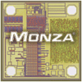

Electronic Product Code (EPC)

The electronic product code (EPC) stored in the tag chip's memory is written to the tag by an RFID printer and takes the form of a 96-bit string of data. The first eight bits are a header which identifies the version of the protocol. The next 28 bits identify the organization that manages the data for this tag; the organization number is assigned by the EPCglobal consortium. The next 24 bits are an object class, identifying the kind of product; the last 36 bits are a unique serial number for a particular tag. These last two fields are set by the organization that issued the tag. The total electronic product code number can be used as a key into a global database to uniquely identify that particular product.

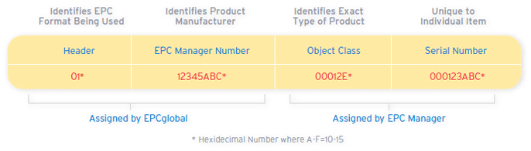

Tag Antennas

Tag antennas collect energy and channel it to the chip to turn it on. Generally, the larger the tag antenna's area, the more energy it will be able to collect and channel toward the tag chip, and the further read range the tag will have.

There is no perfect antenna for all applications. It is the application that defines the antenna specifications. Some tags might be optimized for a particular frequency band, while others might be tuned for good performance when attached to materials that may not normally work well for wireless communication (certain liquids and metals, for example). Antennas can be made from a variety of materials; they can be printed, etched, or stamped with conductive ink, or even vapor deposited onto labels.

Tags that have only a single antenna are not as reliable as tags with multiple antennas. With a single antenna, a tag's orientation can result in “dead zones”, or areas on the tag where incoming signals cannot be easily harvested to provide sufficient energy to power on the chip and communicate with the reader. A tag with dual antennas is able to eliminate these dead zones and increase its readability but requires a specialized chip.

**RFID Readers**

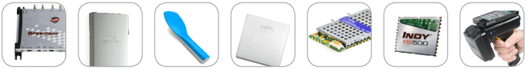

An RFID reader, also known as an interrogator, is a device that provides the connection between the tag data and the enterprise system software that needs the information. The reader communicates with tags that are within its field of operation, performing any number of tasks including simple continuous inventorying, filtering (searching for tags that meet certain criteria), writing (or encoding) to selected tags, etc.

The reader uses an attached antenna to capture data from tags. It then passes the data to a computer for processing. Just like RFID tags, there are many different sizes and types of RFID readers. Readers can be affixed in a stationary position in a store or factory, or integrated into a mobile device such as a portable, handheld scanner. Readers can also be embedded in electronic equipment or devices, and in vehicles.

Reader Antennas



RFID readers and reader antennas work together to read tags. Reader antennas convert electrical current into electromagnetic waves that are then radiated into space where they can be received by a tag antenna and converted back to electrical current. Just like tag antennas, there is a large variety of reader antennas and optimal antenna selection varies according to the solution's specific application and environment.

The two most common antenna types are linear- and circular-polarized antennas. Antennas that radiate linear electric fields have long ranges, and high levels of power that enable their signals to penetrate through different materials to read tags. Linear antennas are sensitive to tag orientation; depending on the tag angle or placement, linear antennas can have a difficult time reading tags. Conversely, antennas that radiate circular fields are less sensitive to orientation, but are not able to deliver as much power as linear antennas.

Choice of antenna is also determined by the distance between the RFID reader and the tags that it needs to read. This distance is called read range. Reader antennas operate in either a "near-field" (short range) or "far-field" (long range). In near-field applications, the read range is less than 30 cm and the antenna uses magnetic coupling so the reader and tag can transfer power. In near-field systems, the readability of the tags is not affected by the presence of dielectrics such as water and metal in the field.

In far-field applications, the range between the tag and reader is greater than 30 cm and can be up to several tens of meters. Far-field antennas utilize electromagnetic coupling and dielectrics can weaken communication between the reader and tags

Reader Control and Application Software

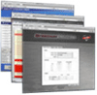 Reader control and application software, also known as middleware, helps connect RFID readers with the applications they support. The middleware sends control commands to the reader and receives tag data from the reader.

**CHAPTER 03  
The Different Types of RFID Systems**

**RFID systems can be broken down by the frequency band within which they operate: low frequency, high frequency, and ultra-high frequency. There are also two broad categories of RFID systems-passive and active.**

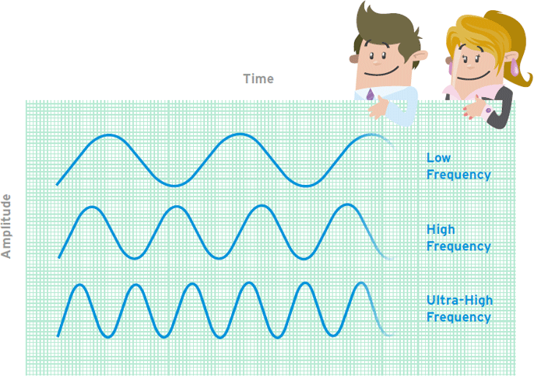

Frequency refers to the size of the radio waves used to communicate between RFID systems components. RFID systems throughout the world operate in low frequency (LF), high frequency (HF) and ultra-high frequency (UHF) bands. Radio waves behave differently at each of these frequencies with advantages and disadvantages associated with using each frequency band.

If an RFID system operates at a lower frequency, it has a shorter read range and slower data read rate, but increased capabilities for reading near or on metal or liquid surfaces. If a system operates at a higher frequency, it generally has faster data transfer rates and longer read ranges than lower frequency systems, but more sensitivity to radio wave interference caused by liquids and metals in the environment.

**LF RFID**

The LF band covers frequencies from 30 KHz to 300 KHz. Typically LF RFID systems operate at 125 KHz, although there are some that operate at 134 KHz. This frequency band provides a short read range of 10 cm, and has slower read speed than the higher frequencies, but is not very sensitive to radio wave interference.

LF RFID applications include access control and livestock tracking.

Standards for LF animal-tracking systems are defined in ISO 14223, and ISO/IEC 18000-2. The LF spectrum is not considered a truly global application because of slight differences in frequency and power levels throughout the world.

**HF RFID**

The HF band ranges from 3 to 30 MHz. Most HF RFID systems operate at 13.56 MHz with read ranges between 10 cm and 1 m. HF systems experience moderate sensitivity to interference.

HF RFID is commonly used for ticketing, payment, and data transfer applications. There are several HF RFID standards in place, such as the ISO 15693 standard for tracking items, and the ECMA-340 and ISO/IEC 18092 standards for Near Field Communication (NFC), a short-range technology that is commonly used for data exchange between devices. Other HF standards include the ISO/IEC 14443 A and ISO/IEC 14443 standards for MIFARE technology, which used in smart cards and proximity cards, and the JIS X 6319-4 for FeliCa, which is a smart card system commonly used in electronic money cards.

**UHF RFID**

The UHF frequency band covers the range from 300 MHz to 3 GHz. Systems complying with the UHF Gen2 standard for RFID use the 860 to 960 MHz band. While there is some variance in frequency from region to region, UHF Gen2 RFID systems in most countries operate between 900 and 915 MHz.

The read range of passive UHF systems can be as long as 12 m, and UHF RFID has a faster data transfer rate than LF or HF. UHF RFID is the most sensitive to interference, but many UHF product manufacturers have found ways of designing tags, antennas, and readers to keep performance high even in difficult environments. Passive UHF tags are easier and cheaper to manufacture than LF and HF tags.

UHF RFID is used in a wide variety of applications, ranging from retail inventory management, to pharmaceutical anti-counterfeiting, to wireless device configuration. The bulk of new RFID projects are using UHF opposed to LF or HF, making UHF the fastest growing segment of the RFID market.

## **Passive, Active, and BAP RFID Systems**

### Active RFID Systems

In active RFID systems, tags have their own transmitter and power source. Usually, the power source is a battery. Active tags broadcast their own signal to transmit the information stored on their microchips.

Active RFID systems typically operate in the **ultra-high frequency (UHF) band** and offer a range of up to 100 m. In general, active tags are used on large objects, such as rail cars, big reusable containers, and other assets that need to be tracked over long distances.

There are two main types of active tags: transponders and beacons. **Transponders** are “woken up” when they receive a radio signal from a reader, and then power on and respond by transmitting a signal back. Because transponders do not actively radiate radio waves until they receive a reader signal, they conserve battery life.

**Beacons** are used in most **real-time locating systems (RTLS)**, in order to track the precise location of an asset continuously. Unlike transponders, beacons are not powered on by the reader’s signal. Instead, they emit signals at pre-set intervals. Depending on the level of locating accuracy required, beacons can be set to emit signals every few seconds, or once a day. Each beacon’s signal is received by reader antennas that are positioned around the perimeter of the area being monitored, and communicates the tag’s ID information and position.

### Passive RFID Systems

In passive RFID systems, the reader and reader antenna send a radio signal to the tag. The RFID tag then uses the transmitted signal to power on, and reflect energy back to the reader.

Passive RFID systems can operate in the **low frequency (LF)**, **high frequency (HF)** or **ultra-high frequency (UHF)** radio bands. As passive system ranges are limited by the power of the tag’s **backscatter** (the radio signal reflected from the tag back to the reader), they are typically less than 10 m. Because passive tags do not require a power source or transmitter, and only require a tag chip and antenna, they are cheaper, smaller, and easier to manufacture than active tags.

Passive tags can be packaged in many different ways, depending on the specific RFID application requirements. For instance, they may be mounted on a substrate, or sandwiched between an adhesive layer and a paper label to create smart RFID labels. Passive tags may also be embedded in a variety of devices or packages to make the tag resistant to extreme temperatures or harsh chemicals.

Passive RFID solutions are useful for many applications, and are commonly deployed to track goods in the supply chain, to inventory assets in the retail industry, to authenticate products such as pharmaceuticals, and to embed RFID capability in a variety of devices. Passive RFID can even be used in warehouses and distribution centers, in spite of its shorter range, by setting up readers at choke points to monitor asset movement.

### Battery-Assisted Passive (BAP) Systems

A Battery-Assisted Passive RFID tag is a type of passive tag which incorporates a crucial active tag feature. While most passive RFID tags use the energy from the RFID reader’s signal to power on the tag’s chip and backscatter to the reader, BAP tags use an integrated power source (usually a battery) to power on the chip, so all of the captured energy from the reader can be used for backscatter. Unlike transponders, BAP tags do not have their own transmitters.

**CHAPTER 04  
RFID Standards**

## **What are RFID standards?**

RFID standards are guidelines or specifications for all RFID products. Standards provide guidelines about how RFID systems work, what frequencies they operate at, how data is transferred, and how communication works between the reader and the tag.

## **Why are RFID standards important?**

RFID standards help ensure that RFID products are interoperable, regardless of the vendor or user. They also provide guidelines by which companies can develop complementary products, such as different types of tags, readers, software, and accessories. Additionally, standards help broaden markets and increase competition within the industry, which brings the prices of standardized RFID products down. RFID standards also help increase widespread confidence in the technology.

## **Who sets RFID standards?**

Standards are developed and issued by industry-specific, national, regional, and global bodies. The more global the standard is, the more bodies are involved in its development. International organizations that issue RFID-related standards include EPCglobal (a GS1 venture), the International Electrotechnical Commission (IEC), the International Standards Organization (ISO), and the Joint Technical Committee (JTC 1), a committee formed by ISO and IEC. Regional regulatory entities that govern the use of RFID include the Federal Communication Commission (FCC), which is in charge of the United States, the European Telecommunications Standards Institute (ETSI), which operates in Europe. Other regions have their own regulatory entities.

Organizations that oversee RFID standards for specific industries include the Association of American Railroads (AAR), the Automotive Industry Standards Group (AIAG), the American Trucking Associations (ATA), and the International Air Transport Association (IATA). Additionally, the GS1 VICS Item Level RFID Initiative (VILRI) oversees standards around item-level tagging and the use of RFID technology throughout the retail supply chain.

**References:**

[**http://www.impinj.com**](http://www.impinj.com)

[**https://fr.wikipedia.org/wiki/Radio-identification**](https://fr.wikipedia.org/wiki/Radio-identification)

[**http://www.technovelgy.com/ct/technology-article.asp**](http://www.technovelgy.com/ct/technology-article.asp)